1st Grade Connection
April 27-May 01, 2026
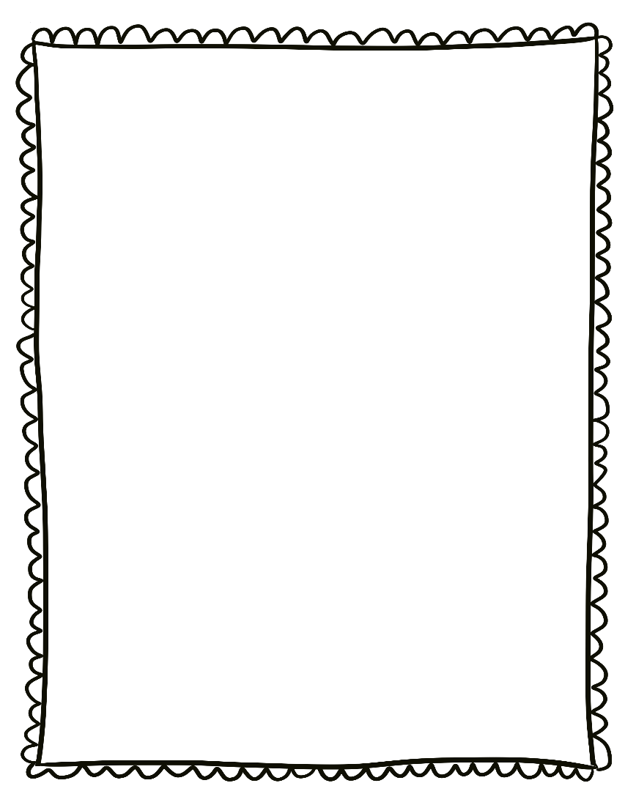
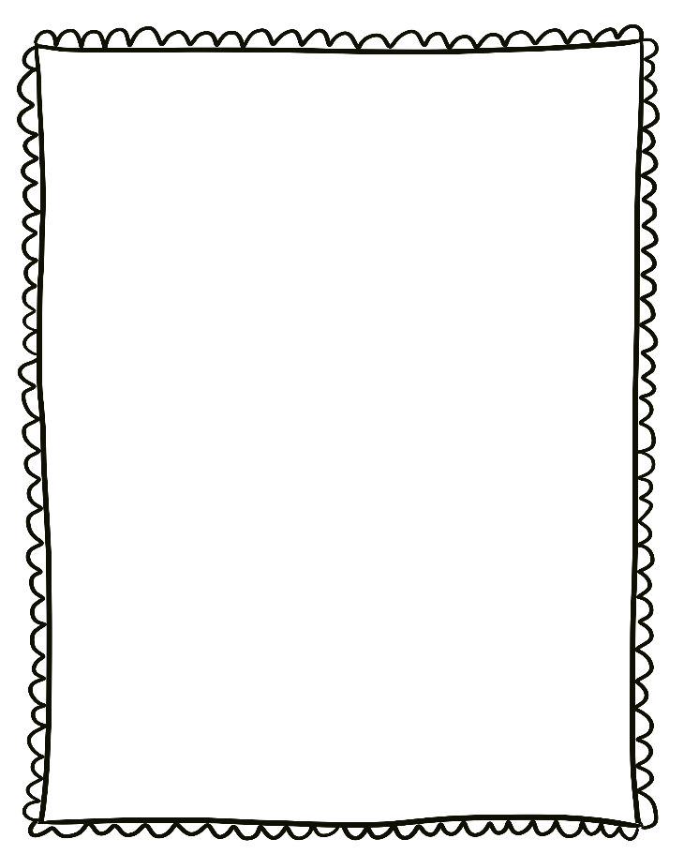
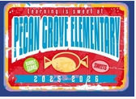
- Monday, April 27-May 01: End of Year MAP Fluency assessment
- Wednesday, April 29th:
College Wear Wednesday

Reminders:

- Please send a nutritious snack that is easy to eat to school with your student. All snacks must be peanut free. Examples of this include Cheez-Its, Pretzels, or baby.
carrots.

- Wear tennis shoes on PE days!

- Reading: Research

- Phonics: R-controlled vowels -er, -ir,
-ur

- Writing: Research

- Conventions: Review

- Math: Measurement and Time

- Social Studies: Jobs

- Science: Structures of Animals

Upcoming Events/Grades
What we are learning:

